IVEDC SENIOR CITIZEN NUTRITION PROGRAM

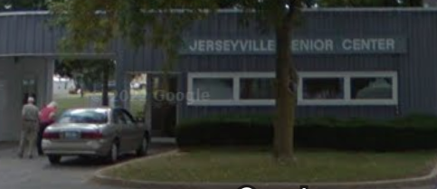
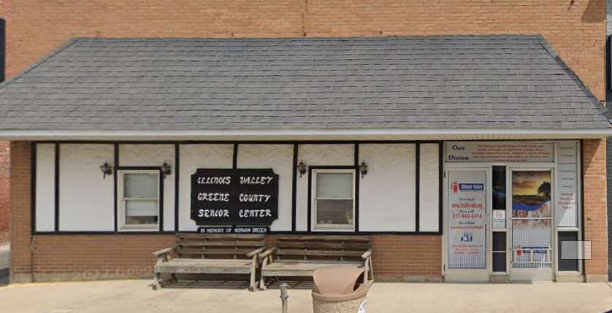
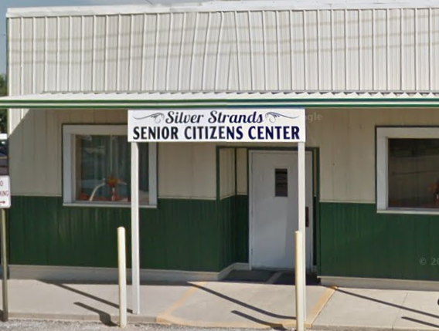
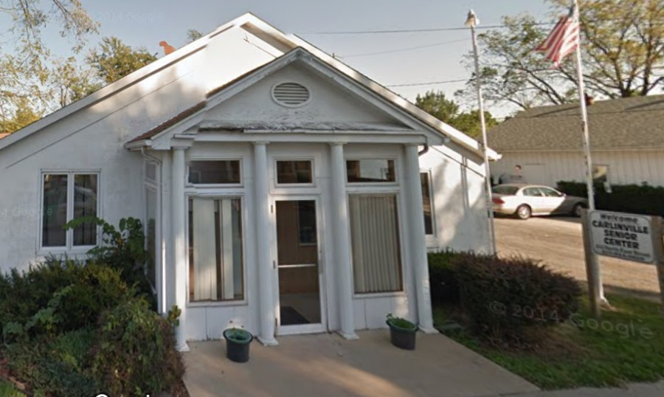
Participant Handbook

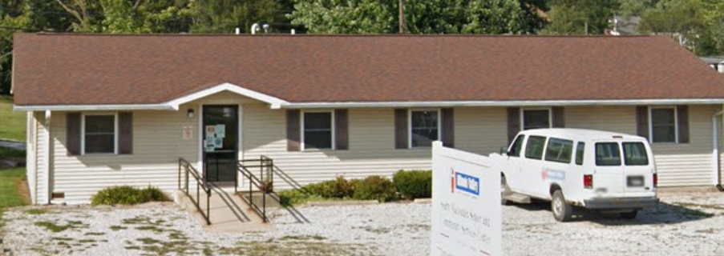

The purpose of the IVEDC Nutrition Program is to assist older Americans to live independently by promoting better health, reducing hunger & food insecurity, promoting socialization of older individuals, and delaying the onset of adverse health conditions resulting from poor nutritional health and sedentary behavior.

It gives us great pleasure to welcome you to the Senior Citizen Nutrition Program operated by Illinois Valley Economic Development Corporation. We hope you will enjoy the wide array of programs, activities, and opportunities we provide. We aim to support older adults in their efforts to remain healthy, active, and independent members of the communities we serve while promoting their dignity and enrichment of life.
We take pride in offering activities and events that are appealing to each program participant, from exercise classes, health and wellness activities, card games, video presentations, BINGO, and nutritious hot daily lunch meals. We do our best to build activities around the needs and wishes of our participants, but we also welcome your suggestions. If there is something you’d like us to add to our programming, please let us know. If there is a way to make it happen, we will do our best to accommodate your requests.
We want everyone to have a positive and enjoyable experience while participating in the nutrition program. This handbook should help everyone understand their responsibilities and expectations associated with participation in senior center activities and as a recipient of our meals. The purpose of developing this handbook is to ensure that all employees, participants, volunteers, instructors, guests, and visitors are provided a safe and pleasurable environment in which to work, learn, play, and join in fellowship. If you have any questions about the information provided, please contact the nutrition administration office at 618-498-3483.

TABLE OF CONTENTS PAGE

Locations & Contact Information……………………………………………………..3
Hours of Operation…………………………………………………………………….4
Holiday Closures……………………………………………………………………….4
Eligibility, Registration Process, & Delivery Schedules……………………………..5
Meal Reservations & Cancellations…………………………………………………..6
General Guidelines of Participation and Conduct…………………………………6-8
Menus / Activity Calendars / Newsletters…………………………………………….8
Meal Costs and Contributions/Donations…………………………………………..8-9
Privacy and Confidentiality…………………………………………………………….9
Inclement Weather & Closures………………………………………………………..9
Center Emergency Procedures …………………………………………………….10-11
Volunteer Opportunities, Information, and In Kind…………………………………..11
Agreements & Appeals…………………………………………………………………12
Locations & Contact Information
IVEDC operates a total of five Senior Citizen Centers: three in Macoupin County, one in Greene County, and one in Jersey County.

Carlinville Senior Citizens Center
213 North East Street
Carlinville, IL 62626
217-854-3622

Silver Strands Senior Citizens Center
133 East State Street
Palmyra, IL 62674
217-436-2497

South Macoupin Senior & Community Service Center
Benld Senior Citizen Center
311 East Central Avenue
Benld, IL 62009
217-835-3174

Greene County Senior Citizens Center
320 Fifth Street
Carrollton, IL 62016
217-942-6414

Jersey County Senior Citizens Center
Nutrition Program Administration Office
PO Box 431
806 East Franklin Avenue
Jerseyville, IL 62052
618-498-3483

Hours of Operation

Each Senior Citizen Center is open Monday through Friday, except on the holidays listed below.
Activities are held either before lunch or after lunch is served, depending on the activity and the senior center hosting the activity. Please verify with your local senior center.
The doors are open, each weekday, between the hours of 8:00 am and 2:00 pm.
Lunch is served each weekday, between 11:30 am and 12:30 pm.
Carry Out meals are available for pickup, each weekday, between the hours of 10:30 am and 12:00 pm.

Holiday Closures
New Year’s Day
Martin Luther King Jr. Day
Lincoln’s Birthday
Washington’s Birthday
Memorial Day
Juneteenth
Independence Day
Labor Day
Columbus Day
General Election Day (applicable years only)
Veterans Day
Thanksgiving Day
Day After Thanksgiving Day
Christmas Eve
Christmas Day
New Year’s Eve

Eligibility and Registration Process

Eligibility for Congregate Meals:
Individuals aged 60 or older and the spouses of those individuals, regardless of age, if the eligible spouse is or has been an active participant in the program.

A meal may also be available to disabled individuals, as defined in the Older Americans Act (OAA), who have not attained 60 years of age but who reside in housing facilities occupied primarily by the elderly at which congregate nutrition services are provided, and individuals with disabilities who reside at home with older individuals who are eligible under the OAA.

Volunteers providing services during meal hours, guests over the age of 60, and staff over the age of 60 are also eligible to receive a congregate meal.

Staff or guests under 60, may be offered a meal if doing so will not deprive an older person of a meal. Staff or guests under the age of 60 are required to pay the full cost of the meal.

Eligibility for Home Delivered Meals:
Individuals aged 60 or over who are frail and/or homebound by reason of illness, incapacitating disability, as defined in the Older Americans Act (OAA) or are otherwise isolated and/or unable to drive. Being homebound encompasses the inability to leave home and/or leaving home would require a considerable and taxing effort. The spouse of the older person, regardless of age or condition, may receive a home delivered meal if, according to criteria determined by the Area Agency on Aging, receipt of the meal is in the best interest of the frail and/or homebound person.

A meal may also be available to disabled individuals, as defined in the Older Americans Act (OAA), who have not attained 60 years of age but who reside in housing facilities occupied primarily by the elderly at which congregate nutrition services are provided, and individuals with disabilities who reside at home with older individuals who are eligible under the OAA.

Registration Process:
To register for Congregate Meal Service and/or Home Delivered Meal Service, simply phone the Nutrition Administration Office at 618-498-3483 to complete the documentation, over the phone with a staff member.

Once the paperwork is completed, Congregate guests and those wishing to pick up meals for carry-out will be allowed to schedule meals immediately.

All Home Delivered Meal registrants will be scheduled for a mandatory face-to-face home visit where a staff member will assess your needs and determine eligibility and priority as required by the Illinois Department on Aging. Misrepresenting the need for home delivered meal service will not be tolerated. This service is intended for the frail/homebound population with a high nutritional risk.

Once the home delivery assessment has been completed and priority/eligibility has been determined, you will be placed on a delivery schedule for Home Delivered Meals. Home Delivered Meal recipients MUST register for a set delivery schedule of either 5 days per week or 3 days per week. When choosing a 3 day per week schedule, those 3 days will be the same days every week. We are not staffed to allow for picking/choosing random delivery days based upon meal selection. Mandatory Annual Reassessments are required to continue participation in the Nutrition Program. Home Delivered Meal participant reassessments will be conducted during a scheduled face-to-face home visit with an IVEDC staff member.

Meal Reservations & Cancellations
ALL Meal Reservations and Cancellations must be made by or before NOON on the day BEFORE you wish to receive a meal or cancel a meal.
If you have future appointments and know you will not be home to receive your Home Delivered Meal, PLEASE notify your local Senior Citizens Center OR the Nutrition Administration Office.
IF a cancellation is NOT received/phoned in and meal delivery is attempted on a day you are not home to receive the meal, delivery services will be discontinued until you contact the center to resume your meal delivery service. TWO unsuccessful delivery attempts where no one was home to receive the meal and the participant did not report a cancellation may result in a 30-day suspension of services.
Telephone numbers are located on page 3 of this handbook.

General Guidelines of Participation and Conduct
- Participants must have a completed registration form on file with the Nutrition Program Administration Office prior to participating in activities and/or receiving meals. Individuals aged 60 and over with the greatest economic/social needs, and low-income minority older individuals will be given priority for participation. There is no fee to register.

- Participants are expected to notify the Nutrition Program Administration Office with updated information any time there is a change of address, phone number, emergency contact, etc. All information will be reviewed annually during the mandatory face-to-face reassessment home visits.

- IVEDC requests all participants receiving meals, whether congregate or home delivered, contribute, or donate for the meal they receive. The suggested donation, per meal, is posted at each site and printed on the monthly menus. Please see page 10 for more information regarding the importance of each contribution/donation.

- All participants receiving a congregate meal at the center must sign in on the attendance sheet each day/time.

- For safety concerns, all Home Delivered Meal participants MUST keep pets either kenneled or contained in a room away from the meal delivery pathway during the time of your meal delivery. Pets should NOT be on a leash or running free outside in the pathway of the meal deliverer, as this presents an unwanted fall hazard. If a pet causes harm to a meal deliverer, your services may be suspended.

- Congregate (dine-in) participants must function independently without assistance or supervision from the staff. Those who require assistance must be accompanied by a companion or aide who provides personal assistance.

- On occasion, minor age children may accompany an individual to the senior center. Minors must be adequately always supervised and respect all others in attendance.

- Congregate (dine-in) participants must maintain a level of personal hygiene consistent with generally accepted standards of health and safety for themselves and others.

- There will be no smoking or use of other tobacco products and electronic smoking devices inside any of the IVEDC Senior Citizen Centers, including public areas and restrooms. A designated outdoor smoking area is available.

- Alcohol, intoxicating beverages, and illegal drugs are prohibited in or around any of the IVEDC Senior Citizen Centers.

- Inappropriate physical contact or language and/or bullying behavior that is obscene, profane, vulgar, aggressive, threatening, abusive, loud, or insulting to others will not be tolerated.

- No weapons are allowed to be carried onto the property or into the senior citizens centers.

- Discrimination will not be tolerated; all persons participating in the senior citizen nutrition program shall be assured fair and equal treatment without regard to race, color, sex, religion, creed, national origin, political affiliation, marital status, financial status, or disability. All participants, volunteers, guests, and staff can expect to be treated with respect and without fear of verbal abuse, sexual harassment, physical violence nor threat of violence.

- Staff are granted full authority to de-escalate any situation that disrupts the normal operations of the center.

- IVEDC Senior Citizens Centers are prohibited to be used for sectarian instruction or as a place for religious worship.

- Lobbying, political advocacy, and promotion or endorsement of political campaigns or candidates is prohibited in all IVEDC Senior Citizens Centers.

- We ask that you do not sell items, raffle tickets, or solicit funds. The senior centers should always be a pleasant place for interaction with one another and where all attendees feel welcome and comfortable.

- We welcome outside vendors who are skilled on a variety of subjects to offer educational opportunities that are of interest to the participants at each site. These vendors are invited to conduct presentations, free of charge, at each site. However, vendors are not permitted to offer a sales pitch for specific products or services during these presentations. Presenters may leave business cards and/or literature in designated areas of the senior center. Presenters are NOT permitted to solicit business after the presentation unless a participant initiates the contact. All vendors and their presentations must be pre-approved by the Nutrition Program Manager.

- Staff and Volunteers are not allowed to accept tips.

- The IVEDC Senior Citizens Centers are not responsible for the security, damage, or theft of any personal belongings or misplaced items of its participants.
Menus / Activity Calendars / Newsletters
All monthly menus are prepared by the IVEDC Nutrition Program Head Cook and approved by a Registered Dietician to follow the meal pattern developed by the Illinois Department on Aging and/or provide one-third of the current Dietary Reference Intakes of the National Academies of Sciences, Engineering, and Medicine and conform to the most recent Dietary Guidelines for Americans.
Activities are found listed on each month’s menu calendar. Each site has different activities scheduled at different times. If you are interested in visiting one of our senior centers outside your local center, please call the Nutrition Administration Office at 618-498-3483 for information regarding each site and the activities which are scheduled.
Monthly newsletters, complete with nutrition education, news, puzzles, and community information may be found on the back side of each monthly menu. If you have anything to add to the newsletter, please inform a staff member at the site you attend. Staff member will notify the office so your information may be included.
Meal Costs and Contributions/Donations
The Older Americans Act (OAA), through grants, federally funds only 39% of the TOTAL cost to provide nutritious meals, safety checks, and friendly visits to senior citizens.
The other 61% of funding to provide these services must come from state/local sources, participant contributions/donations/payment for meals, and local business donations.
WE rely on your contributions to account for over half of the needed funding to sustain this program.
This program was developed to provide a LOW-COST nutritional meal option for senior citizens. The suggested donation for those eligible participants aged 60 and over, requested by IVEDC, is only 1/3 of the actual cost of the meal. Those unable to pay the full suggested donation amount are asked to contribute an amount agreeable to your income. Every monetary donation is vital to the sustainability of the nutrition program.
Individuals not meeting the eligibility criteria may purchase a meal at full cost, as posted at each location.
Contributions/Donations from local businesses, churches, and individuals not receiving the meals are always welcomed and appreciated.
All donations and contributions may be made payable to IVEDC and dropped off at any of the five senior citizens centers or mailed to PO Box 431, 806 East Franklin Avenue, Jerseyville, IL 62052. We thank you, in advance, for your contributions.
To maintain integrity of the intention of the Older Americans Act regarding voluntary contributions, programs must do all the following:
- Provide each older person with an opportunity to voluntarily contribute to the cost of the service.
- Protect the privacy of each older person with respect to his or her contributions.
- Establish appropriate procedures to safeguard and account for all contributions.
- Not deny an older person a service because the older person cannot or will not contribute to the cost of the service.
- Not require a contribution or in any way imply one is required to participate.
Privacy and Confidentiality
Illinois Valley Economic Development Corporation is committed to maintaining and protecting the privacy and confidentiality of the personal information provided by participants, volunteers, staff, vendors, and clients.
It is the duty of all staff and volunteers (active or inactive) to keep the confidentiality of participants or potential participants. Confidentiality does not expire. There is no time limit on how long representatives of the agency are bound to the terms of the confidentiality agreement. All information regarding participants or potential participants is protected unless an official Release of Information Form is signed by the participant.
Additionally, we protect the privacy of each participant’s contribution.
Inclement Weather & Closures
Should inclement weather create hazardous travel conditions in Macoupin, Jersey, and Greene Counties, the Executive Director may decide that conditions warrant an alternate schedule consisting of a late start time or closing of facilities.
We are proactive in keeping all staff, volunteers, and participants safe. Many of our volunteers are older Americans, and it is vital to protect their health and safety.
If it is determined closures are warranted, this will be broadcast on WSMI Radio 106.1 FM or 1540 AM, WJBM Radio 104.7 FM or 1480 AM, and WJIL Radio 97.1 FM or 1550 AM. Additionally, the closure will be posted on the IVEDC Facebook page, other social media outlets, and possibly the IVEDC website, www.ilvalley-edc.org.

IVEDC Senior Citizens Center Emergency Procedures
If a medical emergency should arise, the staff is to use their best judgement in formulating a proper response. Staff must stay with the participant until medical personnel arrive (if applicable), and the participant’s emergency contacts have been notified and advised of the situation. These procedures are to be followed even if they are contrary to the wishes of the affected participant. A person under stress of a medical condition is not always able to make the best decisions as to their immediate care.
IVEDC Senior Citizens Center staff and key volunteers are trained for emergency situations as follows:
Facility Evacuation: Total and immediate evacuation of all employees, participants and guests will take place for the following:
- Fire
- Explosion
- Hazardous Material Spill
- Natural Gas Leak
- Structural Damage
- Violence
- Flood
- Earthquake

Facility “Safe Area” & Temporary Shelter: As a general rule, all employees, participants, and guests will remain in the facility’s designated “safe” area during the following:
- Storm (thunderstorms, windstorms, snow/ice storms)
- Tornado
- Earthquake
The designated “safe area” is indicated on the Emergency Evacuation Escape Route Maps posted in the facility.
!! EMERGENCY EVACUATION ESCAPE ROUTE MAP POSTED AT EACH SITE!!
Emergency Communications: Employees will identify the threat and make everyone aware of the situation and conduct safety requirements accordingly. The Executive Director should be notified upon threat. The Executive Director will work to organize and facilitate media coverage, if necessary, and communicate situation information with employee families and the local community. Only the relevant facts, as they are available, will be provided quickly and proactively, keeping relevant parties informed. Once safe and everyone is accounted for, designated employees will call the Executive Director to provide updated status reports of the incident to include actions taken, problems encountered, and how they were resolved and whether additional help is/was required.
Violent Situations: Employees are trained to pay close attention to unusual or suspicious behavior, strangers lurking around, or any kind of verbal or physical threat. External violent situations are always generally a surprise to everyone involved. In the case of an external threat, the first thing employees are instructed to do is call 9-1-1. Employees must provide leadership to all involved, both during the emergency and for recovery efforts. Once the situation is under control, the employee reporting the situation will phone their supervisor and/or the Executive Director.
Hazardous Chemicals: All centers have on site an MSDS sheet indicating chemicals on site and protective measures and safety precautions for handling, storing, and transporting the chemical.
Tornado drills and fire/evacuation drills are conducted on a regular basis. All occupants of the building are required to participate.
As a participant, you must obey all instructions issued by staff during a drill, and an actual emergency, be familiar with the posted emergency information, and be able to identify the nearest emergency exit and “safe areas” at your center.
If a participant recognizes suspicious or unsafe situations, please report the activity to a staff member immediately.

Volunteer Opportunities, Information, and In-Kind
Volunteers are critical to the success of our organization and the services we provide.
IVEDC offers a wide variety of meaningful volunteer opportunities for people of all ages. Community members who share their time, energy, and talents gain personal satisfaction while helping us provide many valuable services.
Volunteers continue to rise to the challenges we face to help keep older adults safe by providing balanced meals, well-being checks, and most importantly support, to help them remain in their homes and communities.
When you spend time volunteering with seniors, you’ll benefit just as much as they do. We believe rich life experiences are indispensable. If you have a passion for helping others and making your community a healthier, happier place, then we would love to hear from you. Call 618-498-3483 for more information.
In‐Kind Match is defined as the value of property or services contributed by an individual to benefit a grant‐supported service. The IVEDC Nutrition Program is required to meet 15% match to remain compliant with the Grant award. All volunteer time contributes to the required In-Kind match for IVEDC. We ask all volunteers to sign and date the appropriate In-Kind Forms located at each site and/or the meal delivery route sheets used to deliver meals. We must report monthly In-Kind totals, along with signatures of those providing volunteer services, to AgeLinc in Springfield, Illinois.
Agreements & Appeals
By registering for and participating in the IVEDC Senior Citizen Nutrition Program activities and services, an individual agrees to abide by the guidelines set forth on the registration form and this handbook.
If a participant abuses or violates the guidelines and agreement of participation outlined herein, the participant may have services suspended and/or terminated based upon the severity of the violation. Notification will be provided in writing.
If a participant feels they have been discriminated against or mistreated in the provision of services by the agency, the following steps will be followed:
- The matter should first be brought to the attention of staff at the service site for local arbitration.
- If the matter cannot be satisfactorily settled at the local level, the Senior Citizen Nutrition Program Manager and the Executive Director should be notified immediately.
- If the matter cannot be resolved by the Senior Citizen Nutrition Manager and/or the Executive Director at the local level, the matter will be brought, by the Executive Director, to the Governing Board of Illinois Valley Economic Development Corporation. The decision of the Governing Board will be final.

